Ty Briggs
Managing Partner, REDS, LLC
Email: ty@redsbuilding.com
Cell: 435-305-9292
Summary
I am a seasoned real estate developer and capital strategist with more than thirty years of experience acquiring land, entitling complex sites, structuring multi-phase communities, and designing high-performing financial models. My work spans large-scale master planning, golf course communities, water and utility engineering, new-construction vertical rollout, and institutional-grade financing structures. I’m known for solving jurisdictional challenges, negotiating at the municipal and capital-partner level, and delivering projects that balance long-term community value with strong investment performance in excess of $2 billion.
Core Competencies
· Real Estate Development and Project Execution
· Capital Structuring and Private Financing
· Financial Modeling and Analytical Strategy
· Entitlement Strategy and Municipal Negotiation
· Stakeholder Leadership and Partnership Management
· Risk Mitigation and Asset Stewardship

Professional Experience

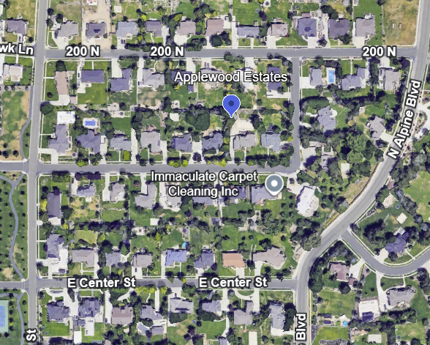
Applewood Estates, Alpine, Utah
Applewood Estates in Alpine, Utah, one of the state’s premier and most challenging municipalities, required sustained negotiation with multiple landowners to assemble and entitle the property. I coordinated the land aggregation, secured the approvals, and structured the development to produce an affluent, cohesive neighborhood of more than sixty single-family homes. The project succeeded in a jurisdiction known for rigorous oversight and complex entitlement pathways, and it stands as a model of disciplined planning, patient execution, and high-quality community design.

The Cedars, Cedar Hills, Utah: 825 units, Championship Golf Course, Municipal Infrastructure Project and City Bonds
I led the full acquisition, entitlement, and development of The Cedars, a master-planned residential and golf-course community in Cedar Hills. I acquired the land at risk, secured all approvals, and advanced the project from raw ground through full completion. The buildout ultimately delivered 825 residential units across four market segments, including 204 townhomes, and I structured the vertical phase by bringing in builders and coordinating their lot absorption schedules.
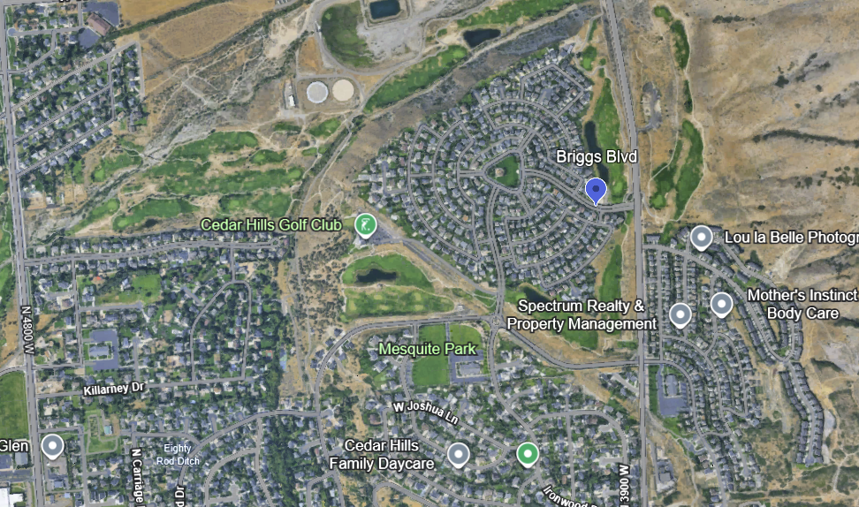For the golf component, I hired Graves & Pascuzzo, including Robert Trent Graves, then President of the National Golf Course Architects Association. I supervised the design process and directed the course layout, ensuring that grading, flow, and neighborhood integration supported both long-term playability and long-term community value. My role included aligning the golf routing with view corridors, the natural topography, and the residential master plan.
I also engineered all major water and utility systems that support the community. This included a seventeen-million-gallon secondary water system, a cross-town collector serving as the community commercial spine, and a two-million-gallon culinary water system. Each system was designed for municipal-grade reliability, future load capacity, and staged expansion by the City of Cedar Hills and the City of Highland. I managed a coordinated dual-city annexation process involving both Cedar Hills and Highland, aligning two municipalities with different political priorities, engineering standards, and growth objectives. I negotiated the land use frameworks, secured service commitments, and unified the annexation boundaries so the project could proceed without jurisdictional conflict. The result was a fully integrated set of approvals that allowed both cities to benefit from the infrastructure, the tax base, and the long-term community plan, while keeping the development on a single cohesive path.
As part of the long-term planning for The Cedars, I helped negotiate a municipal bonding structure that enabled the City of Cedar Hills to acquire the golf course from me. I positioned the transfer as a community benefit rather than a profit event, ensuring the course would be publicly owned, properly maintained, and financially stable. The transaction strengthened the city’s long-term asset base, resolved future operational concerns, and earned us significant recognition for placing community interests ahead of private retention.
The Cedars reflects how I manage complex land acquisitions, entitlement strategy, engineering design, and vertical rollout simultaneously — linking planning, infrastructure, and builder execution as part of a fully integrated development process.

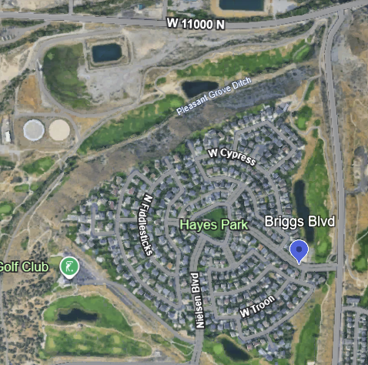

I used a circular street hierarchy to slow vehicle speeds, elevate pedestrian movement, and eliminate the long, repetitive streetscapes that often undermine community character. By organizing the neighborhood into three distinct residential market, each internally cohesive but connected only through the central park corridor, I was able to preserve identity, control traffic flow, and prevent architectural repetition from dominating the visual environment. The enhanced streetscapes, layered landscaping, and intentional separation of product types created a walkable, visually rich community structure. This planning approach proved decisive in the long-term success and absorption strength of the project.
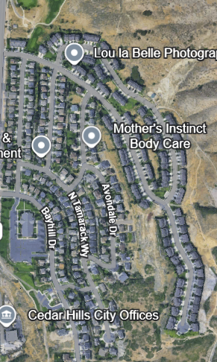
I developed 204 townhome pads on a steep incline that required coordinated work from multiple engineering specialties, including geotechnical analysis, retaining-wall systems, slope stabilization, and stepped-foundation design. The product was intentionally planned to transition into more entry-level homes while still preserving view corridors, which elevated the achievable price point and created a seamless relationship between the higher-density hillside units and the surrounding neighborhoods.

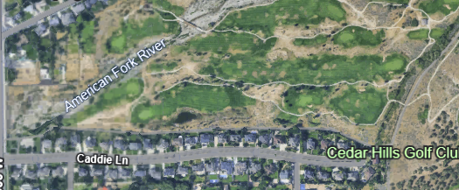
Caddie Lane, Highland, Utah
In Highland, Caddie Lane became the anchor of the high-end segment of the community. I planned and delivered an additional fifty homes that were integrated directly into the golf course setting and aligned along the boundary of the adjacent Alpine Country Club. The streetscape was intentionally elevated with broader setbacks, layered landscaping, and controlled architectural presentation so that the homes carried a distinctly upper-tier feel and strengthened the value relationship between the new neighborhood and the established golf course environment.
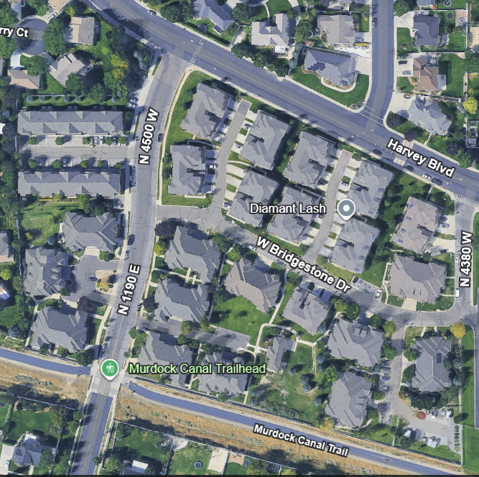
Bridgestone, Pleasant Grove, Utah
Bridgestone was built along the Pleasant Grove boundary and was one of the most architecturally distinctive projects I delivered. The community incorporated underground parking with secure elevator access, allowing the buildings to function as four-plexes while presenting the appearance of large, well-designed single-family homes. Every elevation was treated as a front façade, with proportional massing, rooflines, and detailing that concealed the multifamily structure beneath. This approach created a quiet, high-end character that blended naturally into the surrounding neighborhoods while providing density in a form residents readily embraced.
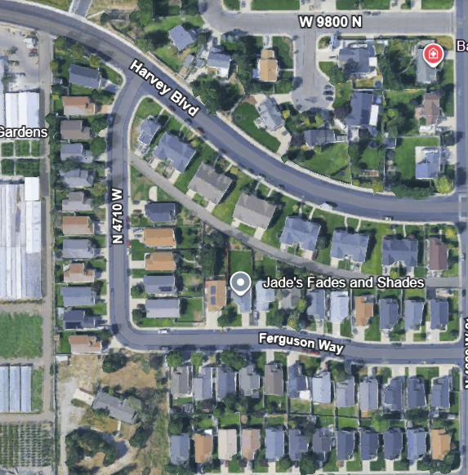
Cedar Run, Cedar Hills, Utah
Cedar Run was an entry-level project designed specifically for affordability. I worked directly with the municipality to rewrite portions of the zoning ordinance, allowing for narrower setbacks and higher density while still preserving a true single-family streetscape. The result was a financially accessible neighborhood that maintained the look and feel of a traditional detached-home community, supported by zoning reforms that balanced municipal objectives with attainable housing.
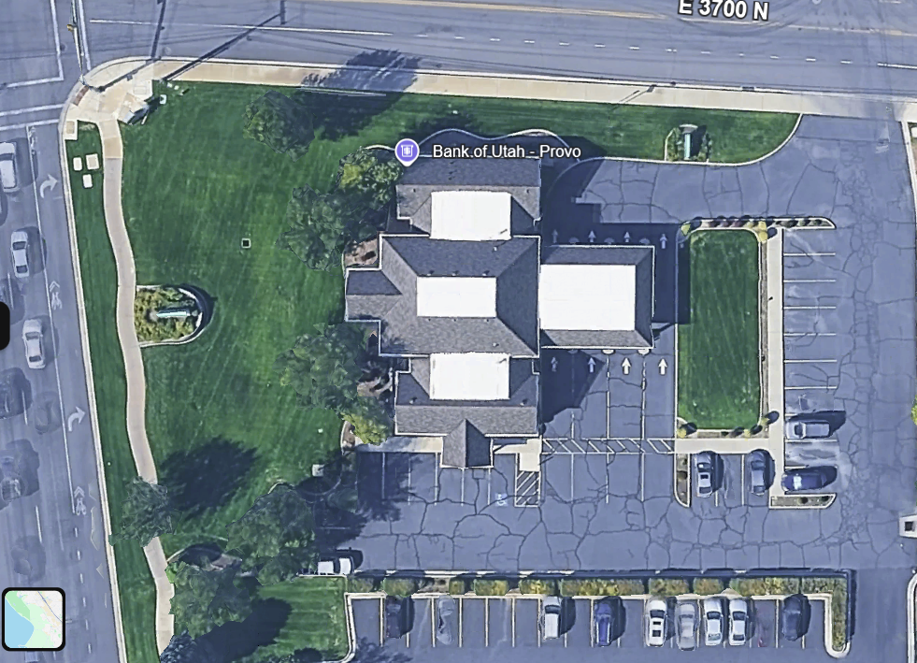
American Bank of Commerce, Provo, Utah
The original American Bank of Commerce, In Provo, Utah (now Bank of Utah) was the first in a series of a dozen architecturally distinctive branch buildings I helped deliver. This initial branch set the design language for the entire system: a culturally elevated, downtown-quality structure and interior carefully placed within a softer suburban community. The architectural presence was strong without being imposing, and the success of this prototype led to the full portfolio of branches being sold together as a single, high-value group.

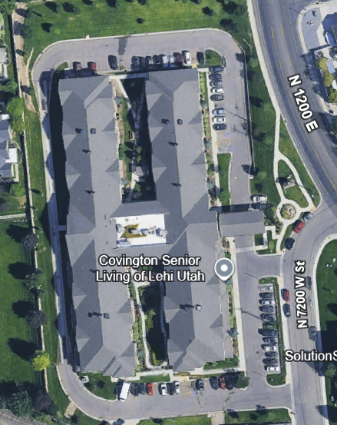
Covington Assisted Living, American Fork, Utah
Covington Living Center was the first in a series of assisted living communities I structured and helped bring to market. I assembled an unusual but highly effective partnership by matching a software company specializing in electronic medical records for correctional systems with the sitting president of the Utah Assisted Living Association. I recruited her to lead the venture, formed a new operating entity around that leadership, and set the organization on a growth trajectory that ultimately produced approximately six assisted living centers and continues to expand.

Across these projects, my role has consistently been to take complex, multi-jurisdictional developments from concept to completion by integrating land acquisition, entitlement strategy, engineering design, and financial structure into a single, coordinated process. Whether building master-planned golf course communities, negotiating zoning reform, assembling high-end neighborhoods in restrictive municipalities, delivering architecturally distinctive mixed-density housing, or creating new operating entities in senior living, the through-line has been the same: I solve difficult problems, unify public and private interests, and produce communities and assets that perform. Each assignment reflects a deliberate approach to design, capital, and execution—linking long-term municipal value with disciplined development strategy.

